**Project Design Phase-II**

**Data Flow Diagram & User Stories**

|  |  |
| --- | --- |
| Date | 28 June 2025 |
| Team ID | LTVIP2025TMID30574 |
| Project Name | Educational Organisation Using ServiceNow |
| Maximum Marks | 4 Marks |

**🔁 Data Flow Diagram (DFD) - Level 1**

**Entities:**

* Admin – manages setup, data entry, and evaluation
* Student – subject of data entry and academic progress
* System Database – stores and processes all relevant data

**Processes:**

1. Student Admission – capturing student personal and admission data
2. Student Progress Entry – entering marks and academic progress
3. Result & Grade Generation – calculating totals, percentages, and results

**Data Stores:**

* D1: Salesforce Table – student personal information
* D2: Admission Table – admission-related data like status
* D3: Student Progress Table – marks, progress, results

**Data Flow Summary:**

* Admin inputs student details → stored in Salesforce Table
* Admission status tracked → in Admission Table
* Marks entered manually → stored in Student Progress Table
* Scripts calculate total, percentage, and result
* Data displayed in the user interface for admin verification

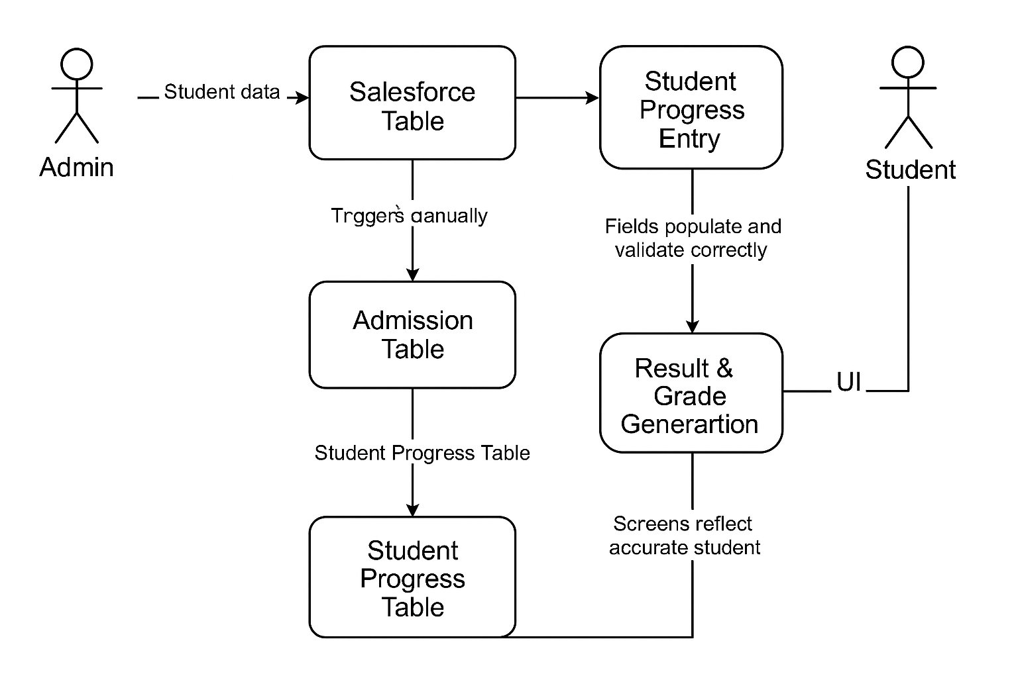

**User Stories**

Use the below template to list all the user stories for the product.

| **S.No** | **User Type** | **Functional Requirement (Epic)** | **User Story Number** | **User Story / Task** | **Acceptance Criteria** | **Priority** | **Release** |
| --- | --- | --- | --- | --- | --- | --- | --- |
| 1 | Admin | Instance Setup | USN-1 | As an admin, I can request and configure a ServiceNow developer instance | Instance is accessible and active | High | Sprint-1 |
| 2 | Admin | Table Creation | USN-2 | As an admin, I can create Salesforce and Admission tables with appropriate fields and choices | Tables are created with correct schema | High | Sprint-1 |
| 3 | Admin | UI Configuration | USN-3 | As an admin, I can design form layouts for student data input | Forms are user-friendly and functional | Medium | Sprint-1 |
| 4 | Admin | Automation Scripts | USN-4 | As an admin, I can configure client scripts to auto-fill and validate fields | Fields populate and validate correctly | High | Sprint-2 |
| 5 | Admin | Admission Process | USN-5 | As an admin, I can define admission status process flow | Admission moves through all status stages | Medium | Sprint-2 |
| 6 | Admin | Progress Evaluation | USN-6 | As a teacher/admin, I can enter marks and calculate result using scripts | Total, percentage, and result auto-generate | High | Sprint-3 |
| 7 | Admin | Output View | USN-7 | As an admin, I can view and verify the student's admission and performance data | Screens reflect accurate student progress | Medium | Sprint-3 |
| 8 | Admin | Testing | USN-8 | As a tester, I can verify all functionalities from input to result generation | All modules pass functional checks | High | Sprint-3 |